Make a Birdhouse Out of a Paperback Book!

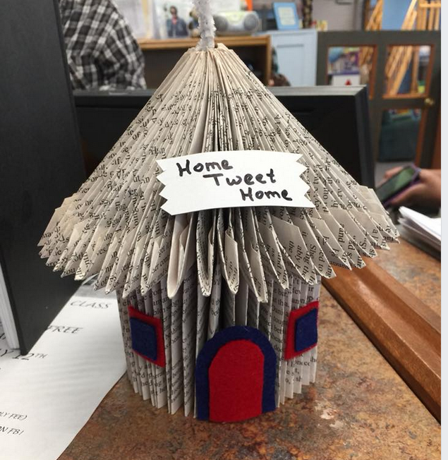

Come and join us on March 20, 2019 at 5:00
as Chris Koagel shows us how to make this adorable birdhouse!
Cost: $3.00 per person
Paperback book provided by the library
Class size is limited, so please reserve your spot by stopping in or calling
315-587-2335

