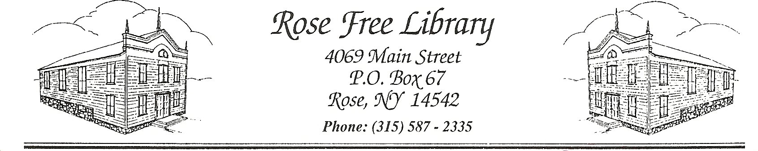
Rose Free Library

Materials Complaint Form
The Rose Free Library Board of Trustees has delegated the responsibility of selection and evaluation of library resources to the staff of the Rose Free Library, and has an established procedure to address patron concerns about those resources. Completion of this form is the first step in this procedure.
Please tell us about the library material you believe was selected for our collection in error.
Author: _____________________________________________________________________
Title: _____________________________________________________________________
Publication Date: ________________ Format (Book, DVD, CD, etc.):
_____________________________
1. What brought this material to your attention?
2. What concerns you about this material? Please be as specific as possible.
3. Have you examined the material in its entirety?
If not, what parts?
4. Do you see any value in the material?
5. What would you like the library to do about this material?
If you wish to remain anonymous, please do not fill in the following section. Instead, submit the form as directed below. Please note that anonymous complaints cannot receive a follow-up from the Library Director.
Name: _____________________________________________________________________
If representing an organization, please name the organization: _____________________ _____________________________________________________________________________________
Address: _____________________________________________________________________
Phone: _____________________________________________________________________
Signature: ____________________________________________________________________
Date: _____________________________________________________________________
Please submit your completed form in a sealed envelope addressed to:
Rose Free Library c/o Library Director
4069 Main St./ PO Box 67
Rose, NY 14542

