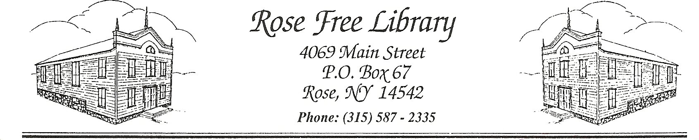
Rose Free Library

Sale or Disposal of Surplus Library Property

- Definition
Surplus Library property is any personal or fixed property owned by the Rose Free Library that is no longer needed for the provision of library services.

- Declaring Property Surplus
Only property having a monetary value need be formally declared surplus.

The Director is authorized to declare as surplus Library materials whose aggregate value is estimated to be less than $1,000.

The Board of Trustees shall formally declare surplus of Library materials and property with an estimated aggregate value of $1,000 or more by resolution. The resolution shall include a listing of the property and its estimated value.

Property valued at $50,000 or more per item may be declared surplus only after a public hearing, following publication of a notice of the hearing in the Finger Lakes Times.

- Disposal and Sale of Surplus Property
Property deemed to have no monetary value shall be disposed of by the most appropriate method to minimize costs to the Library and inconvenience to Library patrons, as determined by the Director or their designee and in accordance with The Town of Rose disposal laws.

Library materials no longer deemed appropriate for the collection will be made available for book sales. As storage space is limited, materials that have not sold within one book sale following their removal from the collection will be donated to nonprofit resellers or local charities, or declared to have no value to such organizations and recycled.

Surplus property, including but not limited to. computer equipment, furniture, fixtures, and supplies no longer of use to the Library and whose estimated aggregate value is less than $1,000, will be first donated or sold for a set amount, determined by the Director or their designee. The property will be sold by the Library via blind auction lasting a minimum of seven business days. The Library reserves the right to use websites such as eBay or Market Place to attract a larger viewing audience. In such instances, as determined by the Director or their designee, options such as a minimum sale price and “buy it now” price may be utilized. Neither Library Board members, employees, nor their families or friends, shall be given or sold Library property unless said property is obtained through the above mentioned sale process. Employees involved in the auction process shall be prohibited from submitting a bid or offer. If no bids are received, the property will be deemed to have no monetary value and disposed of accordingly.

Rotation and replacement of all library computer equipment will be guided by the Library’s Use of Technology by Library Staff Policy in consultation with the PLS Computer and Network Services Department. In accordance with NYS Technology Law, no computer software of a political subdivision shall be transferred if such transfer would cause the disclosure of sensitive information, a breach of a computer software license agreement or an infringement of a copyright.

Surplus Library property whose estimated aggregate value is $1,000 or more shall be disposed of at a public auction to the person submitting the highest bid, following publication of a notice of the auction in the Finger Lakes Times. If no reasonable bids are received, they may be sold as specified above.

The Director will bring to the attention of the Board of Trustees items that may have unusual, historic or artistic value; the Board may engage the services of a professional appraiser for determination of value.

- Exceptions
The Director may dispose of donated items in any legal manner. The Director or their designee is authorized to sell donated items using the closed bid system outlined above for items valued at more than $1,000 or a set price system for items valued at less.

The sales of surplus Library property should be reported to the Board of Trustees as a part of the monthly financial report.

In disposing of property by trade-in on the purchase of a like item, contract shall be awarded according to the provisions of the Library’s Bidding and Procurement Policy.

Adopted by the Board of Trustees:

