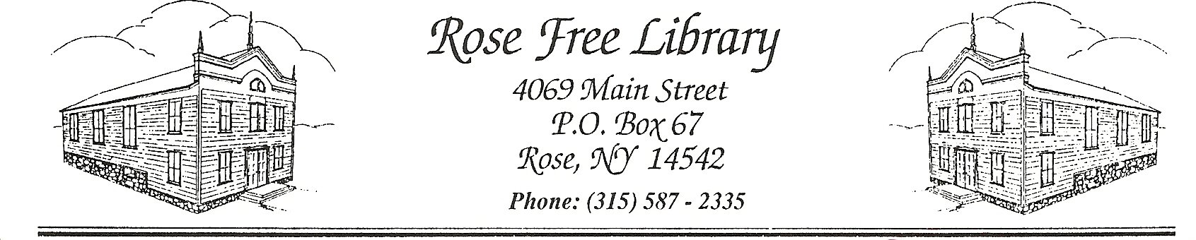
Rose Free Library
Code of Conduct
The Rose Free Library prohibits the following activities and behaviors on its premises. Compliance with this Code is expected of patrons of all ages.
● Committing or attempting to commit a violation of any federal, state, or local ordinance.
● Use of controlled substances, smoking, or other use of tobacco or e-cigarette products.
● Drinking alcoholic beverages, except for in Library-sponsored programs.
● Engaging in sexual conduct or lewd behavior.
● Using Library property in a destructive or dangerous manner.
● Engaging in conduct that disrupts the operation of the Library, or disturbs staff and patrons.
● Use of any communication or entertainment devices at a volume that disturbs others.
● Soliciting or canvassing without express permission of the Library staff.
● Interfering with the free passage of Library staff or users in or onto Library premises.
● Parking vehicles on Library premises for purposes other than library use unless authorized by
Town Board.
● Sleeping on Library property.
● Unhygienic behavior.
● Entering the Library with bare feet or bare chest.
● Disobeying the reasonable direction of Library staff members.

The following guidelines also apply to youth patrons:
● Youth (ages 0-17) are not allowed while school is in session, unless they are accompanied by a
parent, guardian, or tutor.

● Children under the age of ten must be accompanied by an adult, except as approved for Library
programs.
● Guardians are responsible for the behavior of their children in the Library, whether or not the
guardian is present.

Violators of the Code of Conduct are subject to disciplinary procedures.
Please see the Safety Policy and Suspension of Patron Access Policy for complete details.

Approved by the Board of Trustees: 07/20/20
Reviewed by the Board of Trustees: 11/18/2024

