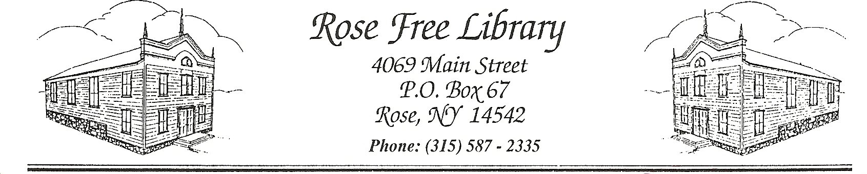
Rose Free Library

Food & Drink Policy

The Rose Free Library maintains a Food and Drink Policy to ensure the continued performance of our computers and other technology as well as the condition of our books, furniture, and other equipment.

No eating is allowed in the Library except in the staff break room, staff offices, or in conjunction with Library approved programs. Covered, spill-proof drinks are allowed in the Library, except near Library computers. Library staff maintain the right to require patrons to remove food and/or drink.

Drinking alcoholic beverages on Library premises is prohibited except for in Library-sponsored programs approved by the Board of Trustees.

Patrons who do not follow the Food and Drink Policy may be prohibited from using computers or other Library equipment, or required to leave the Library.

Approved by the Board of Trustees: 7/20/2020
Reviewed by Board of Trustees: 11/18/2024

