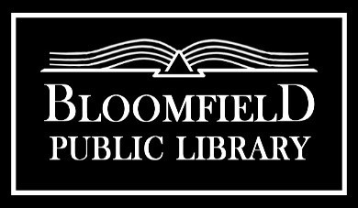
  9 Church Street
  Bloomfield, NY 14469
  585-657-6264
  www.bloomfieldpubliclibrary.org

BUDGET POLICY
Adopted 10/15/18. Revised 4/17/23.

The Bloomfield Public Library ("Library") operates on a July 1 - June 30 fiscal year.

In January of each fiscal year, the Library Director shall draft a proposed operating budget for the next fiscal year.

The operating budget for the Library should reflect that the proceeds of the Library tax levy will be received by the Library from the Bloomfield Central School District ("BCSD") as early as October of the calendar year, and may be received in a single one-time payment or
in several payments at different times.

This draft proposed budget shall be reviewed and developed by the Budget, Finance & Personnel Committee ("Finance Committee") of the Board of Trustees ("Board") of the Library.

The Finance Committee shall finalize its work and present a proposed operating budget to the Board during its regularly scheduled open public meeting in February. The Board shall approve an operating budget by vote at its next regularly scheduled open public meeting.

If an increase in the Library tax levy on the BCSD tax bill is not required by this operating budget, the Board's approval of it shall be final.

If an increase in the Library tax levy on the BCSD tax bill is required by this operating budget, the Board shall notify the Board of Education of the BCSD and request that the increase be placed on the ballot for voter approval.

If the voters approve the increase, the Board shall meet as soon as reasonably possible thereafter to finalize its approval of the operating budget.

If the voters disapprove the increase, the Board shall meet as soon as reasonably possible thereafter to approve a revised operating budget that does not require a tax increase, or to repeat the above process of seeking voter approval.

The Board may review and amend a finally- approved operating budget at any time during the fiscal year at a regularly scheduled open public meeting, provided that any such amendment does not require an increase in the Library tax levy.

