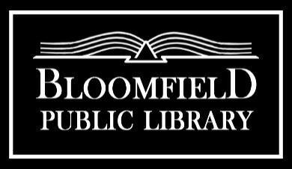

Board Meeting Agenda
Monday, October 21st, 7PM

Call to Order:
1. | Public Comment Period | Cydney Badger
2. | October 21st, 2024 Agenda | Cydney Badger | Action: Approve
3. | Minutes of the September 16th Board Meeting | Cydney Badger | Action: Approve

Communication and Reports:
1. | Treasurer Report | Donna Wollschleger | Action: Approve
2. | Financial Reports  - Warrants (list of bills paid)  - Cash Activity Report  - YTD Report | Donna Wollschleger | Action: Approve  Action: Approve  Action: Approve
3. | Director’s Report | Rachael Aycock | Action: Approve
4. | Committee Reports  - Budget/Finance/Personnel  - Governance  - Facility  - Planning |  | Action: Approve
5. | Friends Liaison Report |  | Action: Review

Old Business:
1. | FOTL MOU | Rachael Aycock | Action: Review/Sign
2. | Library Closures- Lunar New Year | Cydney Badger | Action: Approve

New Business:
1. | Online Banking Policy | Rachael Aycock | Action: Approve
2. | Reserve Fund Policy | Rachael Aycock | Action: Approve
3 | Travel Policy | Rachael Aycock | Action: Approve
4. | Technology Policy | Rachael Aycock | Action: Approve
5. | Emergency Closing Policy | Rachael Aycock | Action: Approve
6. | Library Hours-Winter Hours | Rachael Aycock | Action: Approve
7. | Facility Update  -Snow Plow Service, HVAC, Exit Light Repair, | Rachael Aycock | Action: Update
8. | Construction Grant  -drinking fountain, fence, drywall, deadline,  building permit | Rachael Aycock | Action: Update
9. | Funds Request to School | Cydney Badger | Action: Sign/Assign Action
10. | Disability Premium | Rachael Aycock | Action: Update
11. | Budgetary Recommendations | Rachael Aycock | Action: Approve
12. | DLD Feedback | Cydney Badger | Action: Review
Reminders:
1. | Next Meeting is November 18th, 2024

Adjourn:

