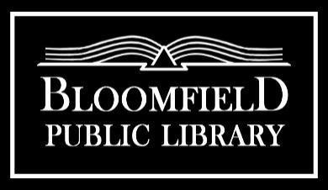

Board Meeting Agenda
Monday, November 18th, 7PM

Call to Order:
1. | Public Comment Period | Cydney Badger
2. | November 18th, 2024 Agenda | Cydney Badger | Action: Approve | 2411-1
3. | Minutes of the October 21st, 2024 Board Meeting | Cydney Badger | Action: Approve | 2411-2

Communication and Reports:
1. | Treasurer Report | Donna Wollschleger | Action: Approve | 2411-3
2. | Financial Reports  - Warrants (list of bills paid)  - Cash Activity Report  - YTD Report | Donna Wollschleger | Action: Approve  Action: Approve  Action: Approve | 2411-4  A  B  C
3. | Director’s Report | Rachael Aycock | Action: Approve | 2411-5
4. | Committee Reports  - Budget/Finance/Personnel  - Governance  - Facility  - Planning |  | Action: Approve | 2411-6  A  B  C  D
5. | Friends Liaison Report |  | Action: Review | 2411-7

Old Business:
1. | FOTL MOU | Rachael Aycock | Action: Sign | 2411-8
2. | Budget Revisions | Cydney Badger | Action: Approve | 2411-9
3. | Construction Aid Funds | Rachael Aycock | Action: Approve/Follow Up | 2411-10

New Business:
1. | Investment Policy | Rachael Aycock | Action: Approve | 2411-11
2. | Open Meetings Policy | Rachael Aycock | Action: Approve | 2411-12
3 | Circulation Policy | Rachael Aycock | Action: Approve | 2411-13
4. | November RPC | Rachael Aycock | Action: Approve | 2411-14
5. | Code of Conduct/Patron Concerns | Rachael Aycock | Action: Discuss | 2411-15
6. | Board Recruitment Efforts | Cydney Badger | Action: Update | 2411-16
7. | Budget Committee Meeting | Cydney Badger | Action: Schedule | 2411-17
8. | Budget Vote/Budget Requirements | Cydney Badger | Action: Discuss | 2411-18
9. | Board Meeting Time Change | Cydney Badger | Action: Approve
Reminders:
1. | Next Meeting is December 16th , 2024

Adjourn:

