2024 Tax Information
It's that time of year again! Here you can find information for both New York State and Federal Income Taxes.
Please note that we are unable to advise you about forms to use or give you tax advice, but we do want to help direct you to the right information.
The Mount Morris Library has received limited copies of tax forms from the IRS and New York State Department of Taxation and Finance. If you need Tax Guides, forms, publications, or help filing your taxes from AARP Tax Volunteers locally, please check the information we listed down below.
AARP Tax Assistance: https://www.aarp.org/money/taxes/aarp_taxaide/
Tax Filing Information
Federal Tax Filing Information
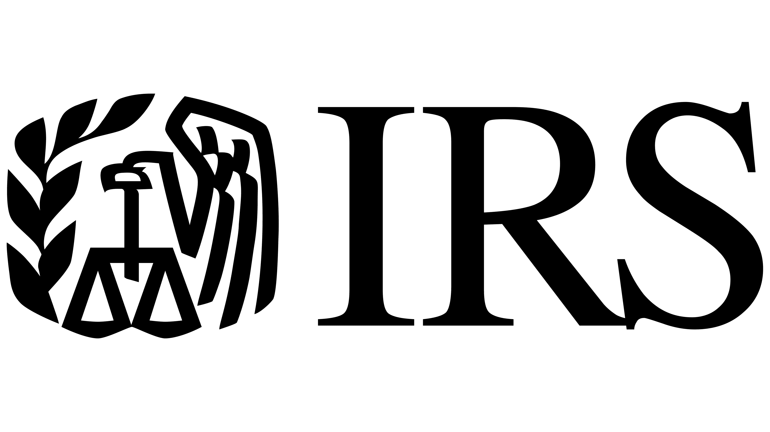
- 2024 Federal Tax Forms and Instructions
- Free Tax Return Preparation for Qualifying Taxpayers
- Frequently Asked Questions When Filing Your Federal Tax Return
- Interactive Tax Assistance Search (ITA)
- How to Protect Yourself Against Fraud and Scams
- How to Check Your Refund Status
- Information for Tax Professionals
- Internal Revenue Service in Spanish
Internal Revenue Service Contact Information: 1-800-829-3676
To download and print IRS Federal tax forms: irs.gov/forms
To order tax products to be delivered by mail: irs.gov/orderforms
NY State Tax Filing Information

- 2024 New York State Forms and Instructions
- Filing How To's
- How to Check Your Refund Status
- How to e-File for Free
- How to Report Fraud and Scams
- NYS Publications & Guidance
- NY State Taxpayer Rights
Forms 1-518-457-5431
Information 1-518-457-5181
Refunds 1-518-457-5149

