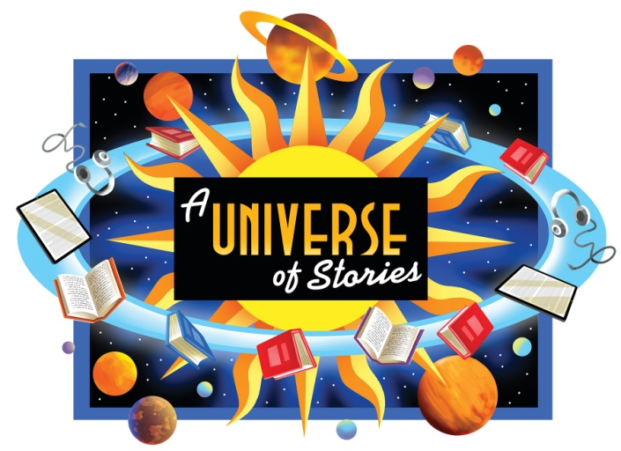
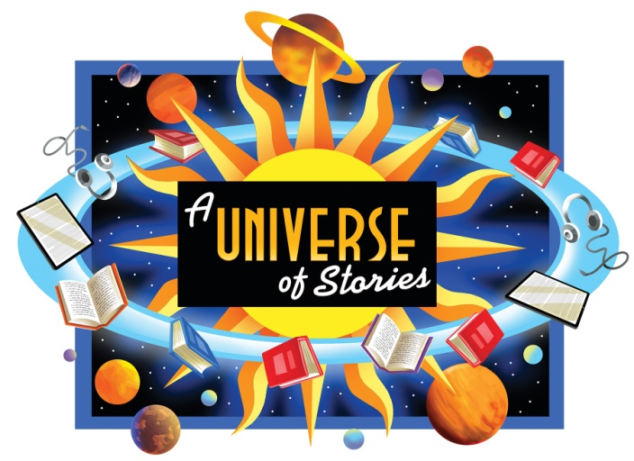

JULY 17 CHARLIE CHECKERS
- Magic Show

JULY 24 OMNIPRESENTS PUPPET THEATER
- Cosmic Joe and the Star Pirates

JULY 31 BUFFALO MUSEUM OF SCIENCE
- Bubble Blast

AUGUST 7 DIDGERIDOO DOWN UNDER
- Music Fun

AUGUST 14 MOVIE
- Ice Cream and Popcorn Provided

JULY 17 CHARLIE CHECKERS
- Magic Show

JULY 24 OMNIPRESENTS PUPPET THEATER
- Cosmic Joe and the Star Pirates

JULY 31 BUFFALO MUSEUM OF SCIENCE
- Bubble Blast

AUGUST 7 DIDGERIDOO DOWN UNDER
- Music Fun

AUGUST 14 MOVIE
- Ice Cream and Popcorn Provided

