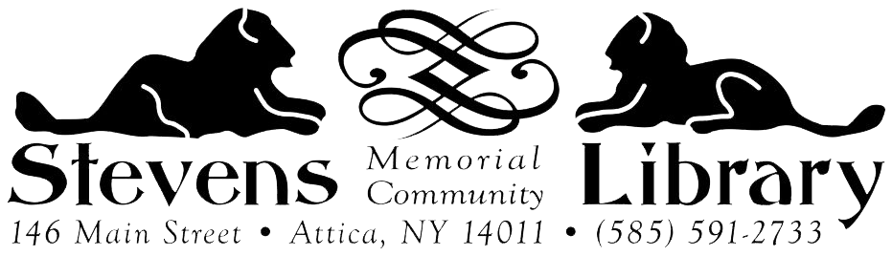

MEETING ROOM POLICY

The use of the meeting room at Stevens Memorial Community Library is primarily for programs conducted or sponsored by community groups and non profit organizations whose missions are educational, cultural, and/or for civic betterment. All groups looking to use the meeting room must submit a Meeting Room Agreement to receive the space. Reservations should be made as soon as possible and will be filled on a first come, first served basis. Applications are available at the circulation desk and on our website.

General Rules of Use:

- Library sponsored programs receive first consideration.
- The meeting room is not available for political or partisan purposes, or for the benefit of private individuals or commercial use. Sale of merchandise (i.e. literary events) is at the discretion of the library director.
- Number of individuals attending the event may not exceed the limit set by Fire Code Regulations. The capacity in the Reading Room is limited to 10. The capacity in other areas of the library may be limited. If you have a large group beyond 25-30, the library may not be able to accommodate your request.
- There is no charge for using the meeting rooms, donations can be made at any time.
- The library should be notified if the group needs to cancel.
- No admission fee may be charged for entrance to an event in the meeting room. A sponsor of a meeting or program may request a fee that covers the cost of materials to participants.
- Meeting spaces may only be used during library open hours. The main contact person is responsible for setting up before and cleaning up after the event.
- Other than as a designation of location, the name of the library may not be used in any publicity relating to the use of the meeting room.
- The library will not be responsible for personal belongings of those attending a meeting or event.
- Refreshments may be served at the responsibility of the group, including set up and clean up.
- Tobacco use and vaping is not permitted on library grounds, inside or outside.
- Events must be conducted in such a way as to not disturb regular library operations.
- Library personnel must have free access to meeting rooms at all times. The library retains the right to monitor al events conducted on library premises.
- The main contact person of the group assumes responsibility for participant accommodations and specific articles of compliance as required by the Americans with Disabilities Act.
- Arrangements for use of any library owned equipment must be made well in advance of the event. If any assistance is needed in equipment set up, please make arrangements at the time of the reservation. Do not assume library personnel working at the time of the event will be able to assist.
- The main contact person of the group accepts liability for either damage to library facilities or loss of library property and liability of any claims for injuries or damage to individuals arising from the use pf the premises by the organization.
- The library director is authorized to deny permission to use the library meeting room and other spaces to any group that is disorderly, or has violated these regulations in the past.

Failure to comply with any of the above rules may be grounds for declining future meeting room usage.

It is hereby recognized that the Board of Trustees and staff shall not violate any local, county, state, or federal regulations and it is acknowledged that rules established by law making agencies may take precedence over policies established by the board.

Adopted by the SMCL Board of Trustees August 9th, 2021

