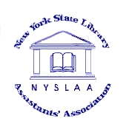
New York State Library
(Office use only)
Date processed:
Member number:
Membership year:
New Member
Assistants' Association
Membership Application for
National Library week

Name: |  |  |  | Title:
Institution Name:
Library Name:
Library Address:
Library City: |  |  |  | State: |  | Zip:
Library Phone: |  |  |  | Email:
Home Address:
Home City: |  |  |  | State: |  | Zip:
Home Phone:

NYSLAA's membership year runs from January 1st through December 31st.

Mail completed form to: Donna Hanna
SUNY Geneseo
Milne Library
1 College Circle
Geneseo, NY 14454-1498

Scan/email to: hanna@geneseo.edu
Questions? Feel free to call Donna: 585-245-5508

Rev 3/2022

